Test-Driven Development

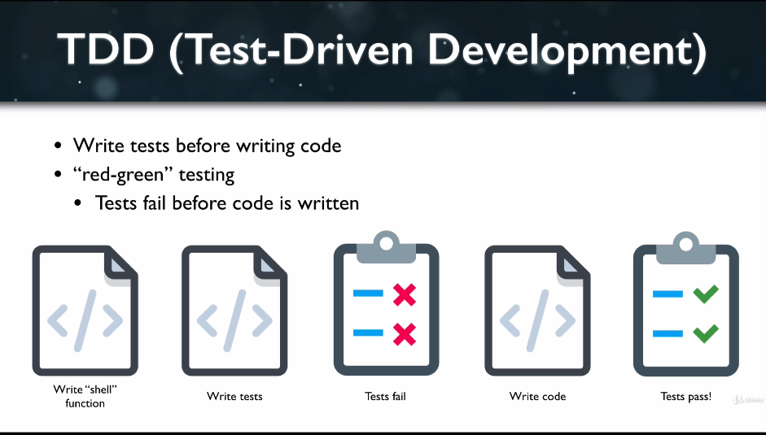

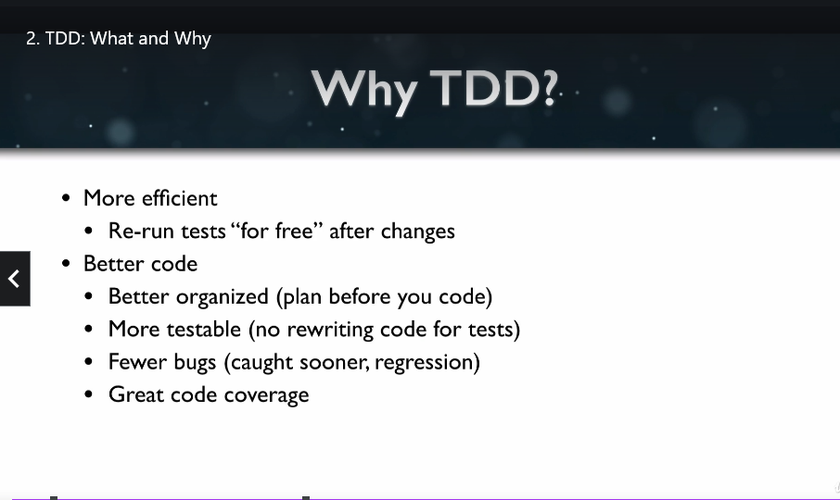

Npm install –save-dev jest babel-jest

jest.config.js

By default watch mode only runs test if the code differs from last commit

Press a 🡪 to run all test

Jest runs files with .test.js files

Enzyme vs React-Tesing-Library

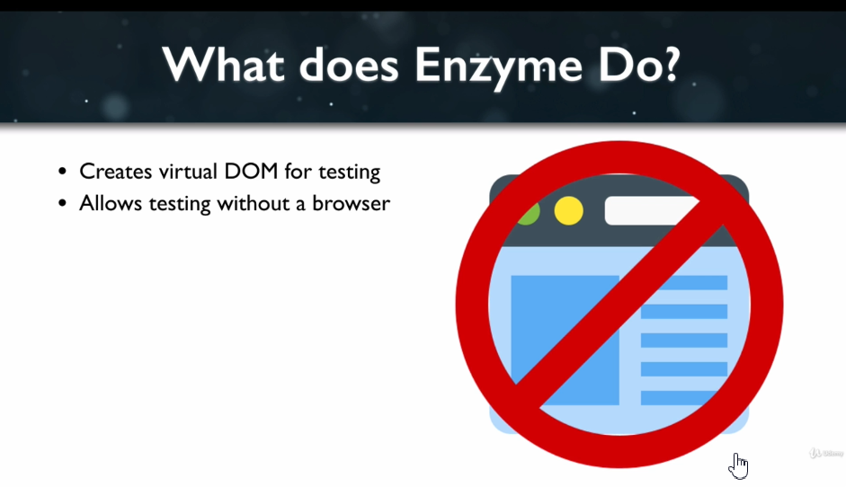

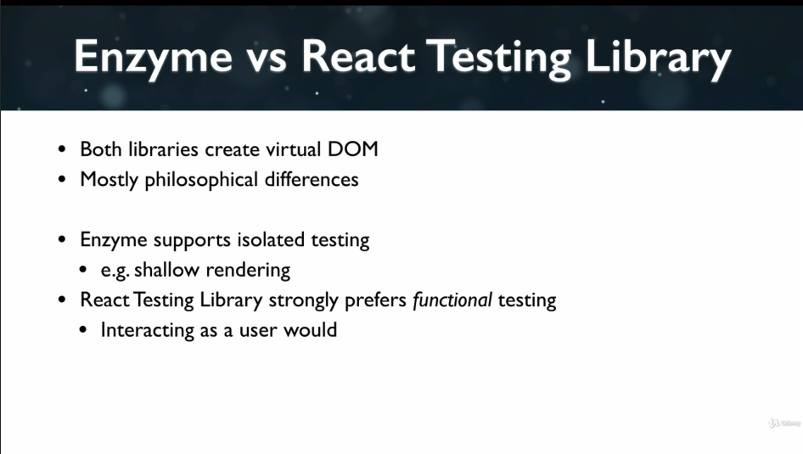

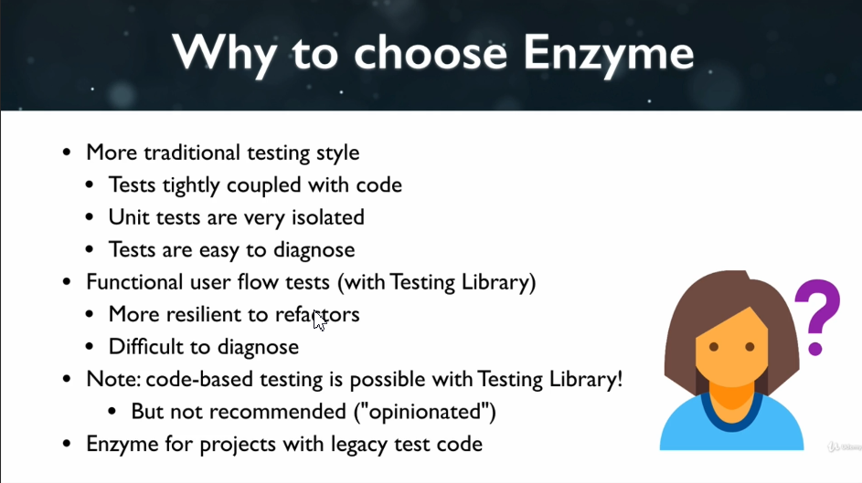

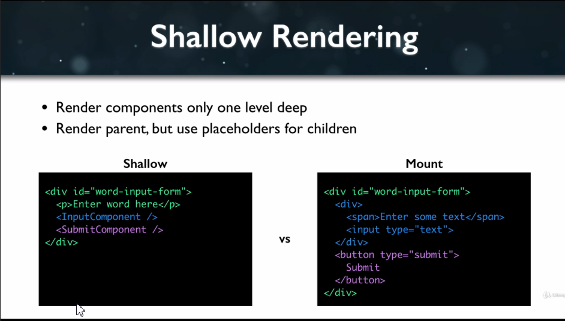

Enzyme install

Npm install –save-dev enzyme @wojtekmaj/enzyme-adapter-react-17

React Testing Library

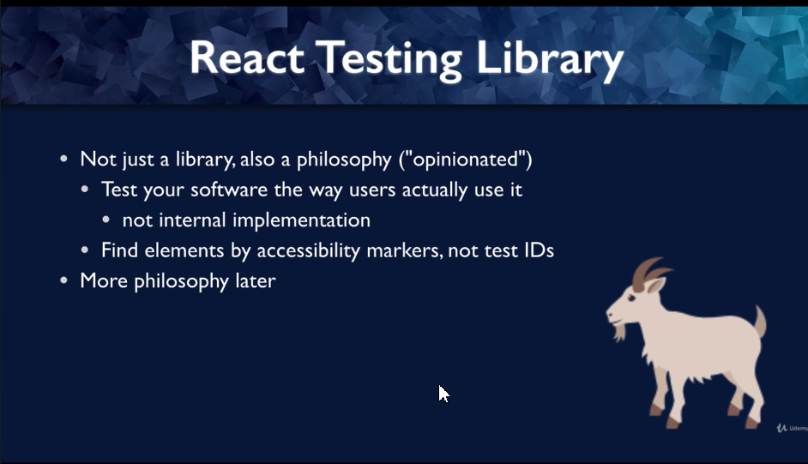

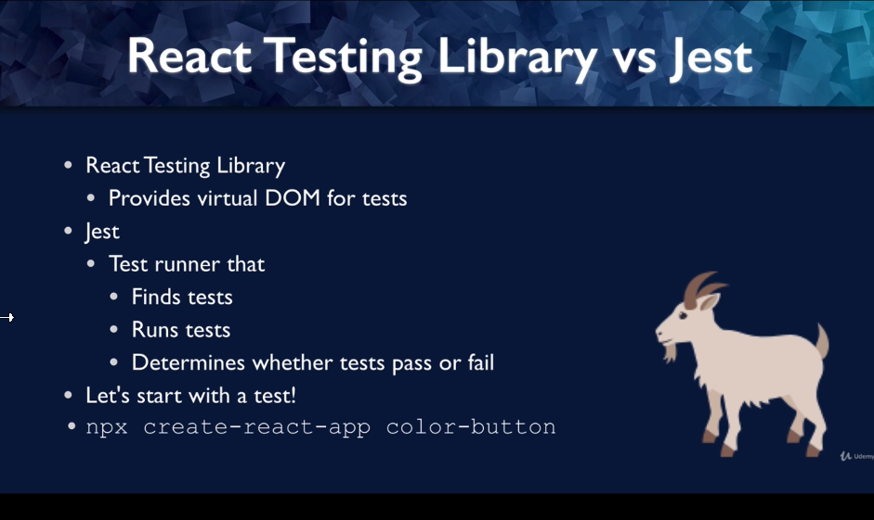

import { render, screen } from '@testing-library/react';

import App from './App';

test('renders learn react link', () => {

  render(<App />);

  const linkElement = screen.getByText(/learn react/i);

  expect(linkElement).toBeInTheDocument();

});

Render 🡪 create virtual DOM for argument JSX

Screen 🡪 access virtual DOM via screen global

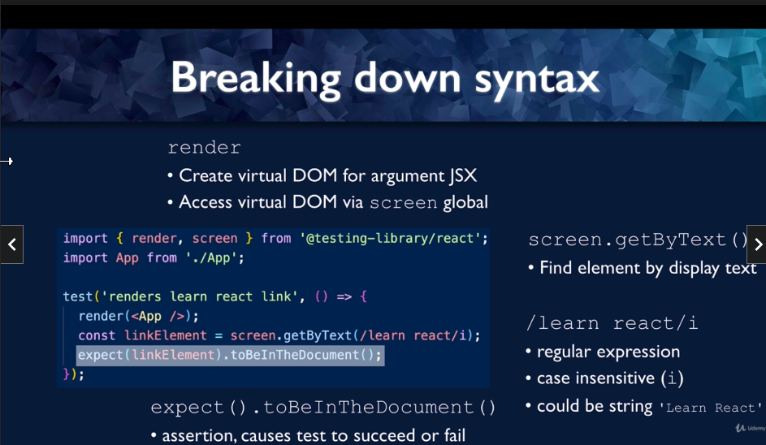

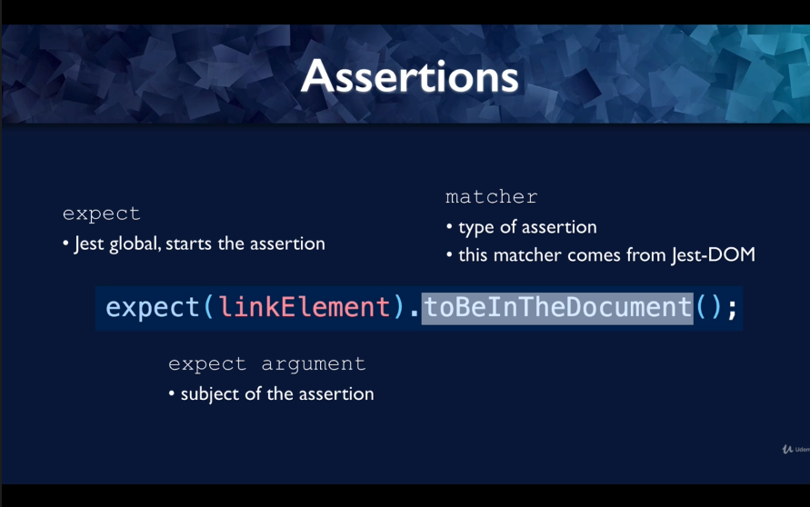

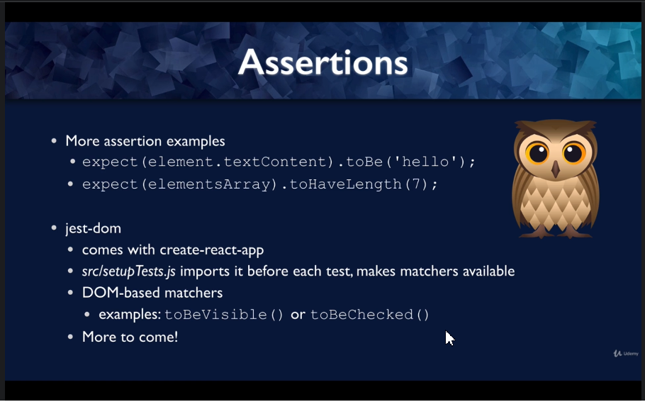



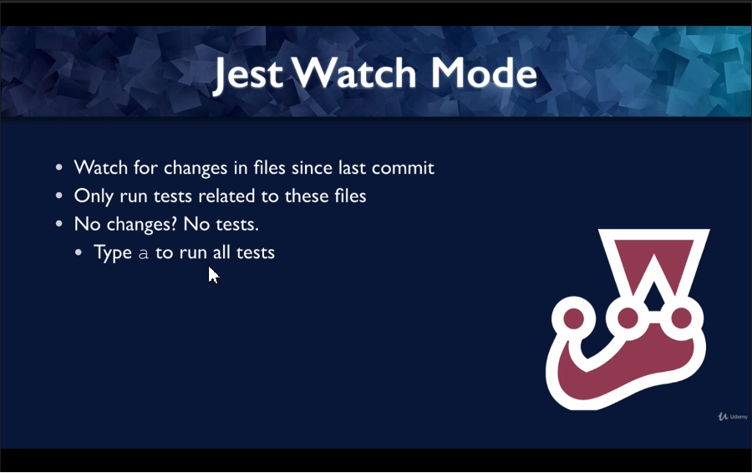



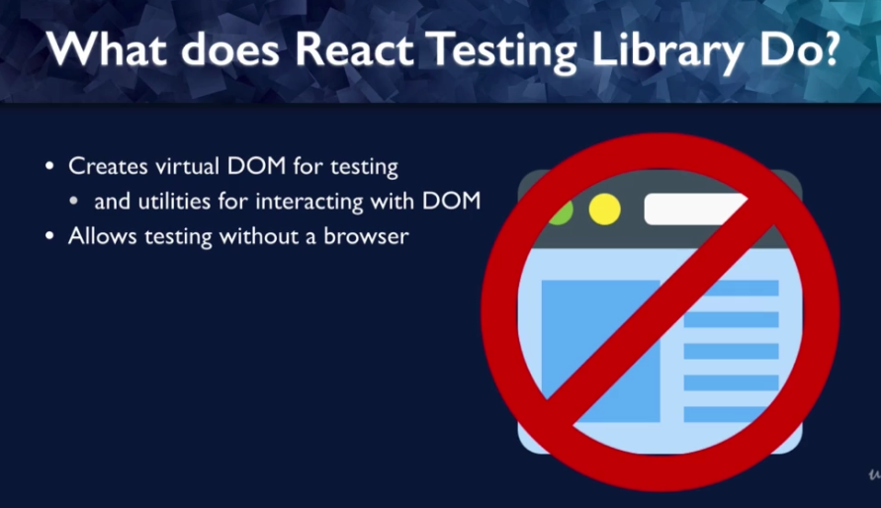

Types of Tests

1. Unit test 🡪 tests one unit of code in isolation
2. Integration test 🡪 How multiple units work togrther
3. Functional or Behavioural tests 🡪 Tests a particular function of software
4. Acceptance/ End-to-End tests 🡪 Use actual browser and server (Cypress,Selenium)

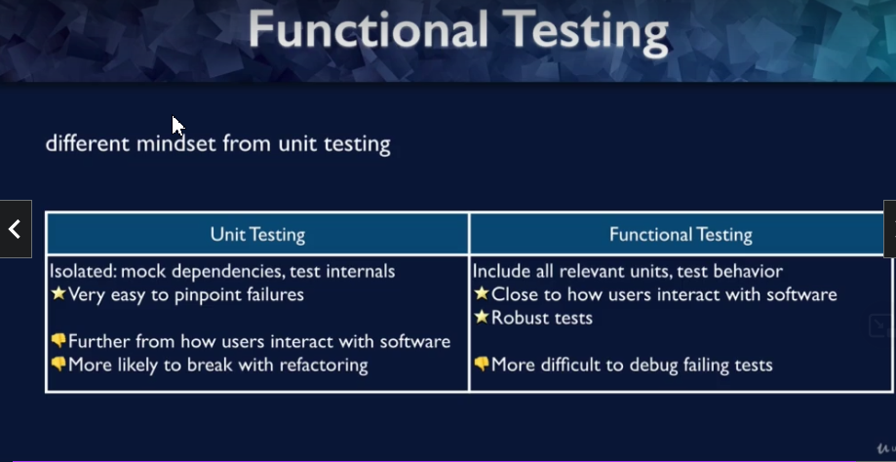

Behavior-Driven Development 🡪 involves collaboration between rot of roles and defines process for different groups to interact

test('renders learn react link', () => {

  render(<App />);

  const linkElement = screen.getByRole('heading', {

    name: /learn react testing/i,

  });

  expect(linkElement).toBeInTheDocument();

});

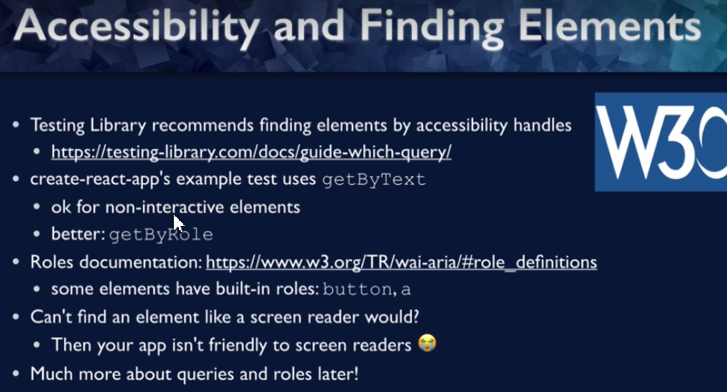

<https://testing-library.com/docs/queries/about/#priority>

<https://www.w3.org/TR/wai-aria/#role_definitions>

import { useState } from 'react';

import './App.css';

function App() {

  const [color, setColor] = useState('red');

  const newButtonColor = color === 'red' ? 'blue' : 'red';

  return (

    <div>

      <button

        onClick={() => setColor('blue')}

        style={{ backgroundColor: color }}

      >

        Change to {newButtonColor}

      </button>

    </div>

  );

}

export default App;

For functional testing multiple assertions can be done in a single test block as it is convenient

import { render, screen, fireEvent } from '@testing-library/react';

import App from './App';

test('button has correct initial color', () => {

  render(<App />);

  // find an element with a role of button and text of 'Change to blue'

  const buttonElement = screen.getByRole('button', { name: 'Change to blue' });

  expect(buttonElement).toHaveStyle({ backgroundColor: 'red' });

  //click button

  fireEvent.click(buttonElement);

  // expect the background color to be blue

  expect(buttonElement).toHaveStyle({ backgroundColor: 'blue' });

  // expect the button text to be 'Change to red'

  expect(buttonElement.textContent).toBe('Change to red');

});

Manual Acceptance Testing

To test the css styles

<https://www.npmjs.com/package/jest-transform-css>

<https://www.npmjs.com/package/jest-css-modules-transform>

Another possibility would be to check explicitly for the class name (hidden in this example), using [toHaveClass](https://github.com/testing-library/jest-dom#tohaveclass). This would be simpler, but farther from the actual user experience (this is testing implementation details, rather than how the user sees the page). It's always a balance, and I think either this approach or transforming the CSS would be defensible.

Unit Testing Functions



export function replaceCamelWithSpaces(colorName) {

  return colorName.replace(/\B([A-Z])\B/g, ' $1');

}

describe('spaces before camel-case capital letters', () => {

  test('Works for no inner capital letters', () => {

    expect(replaceCamelWithSpaces('Red')).toBe('Red');

  });

  test('Works for one inner capital letters', () => {

    expect(replaceCamelWithSpaces('MidnightBlue')).toBe('Midnight Blue');

  });

  test('Works for multiple inner capital letters', () => {

    expect(replaceCamelWithSpaces('MediumVioletRed')).toBe('Medium Violet Red');

  });

});



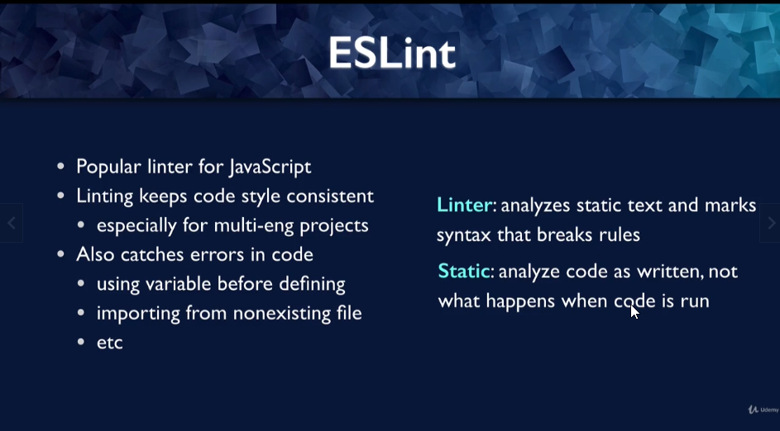



.eslintrc.json

{

  "plugins": [

    "testing-library",

    "jest-dom"

  ],

  "extends": [

    "react-app",

    "react-app/jest",

    "plugin:testing-library/recommended",

    "plugin:testing-library/react",

    "plugin:jest-dom/recommended"

  ]

}

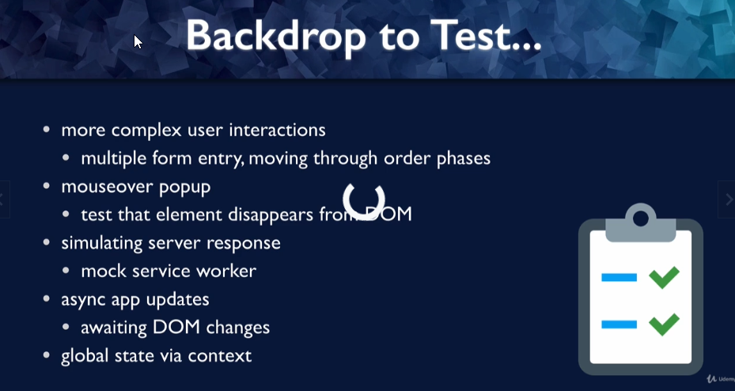

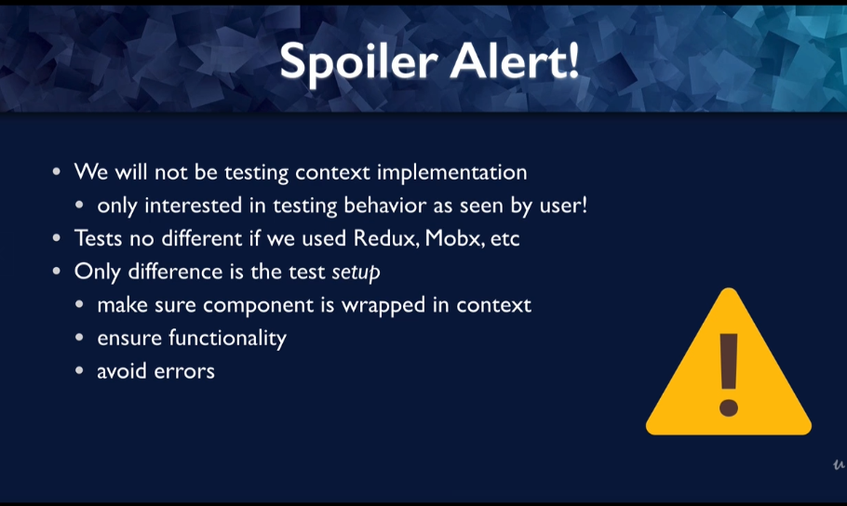

Application Demo

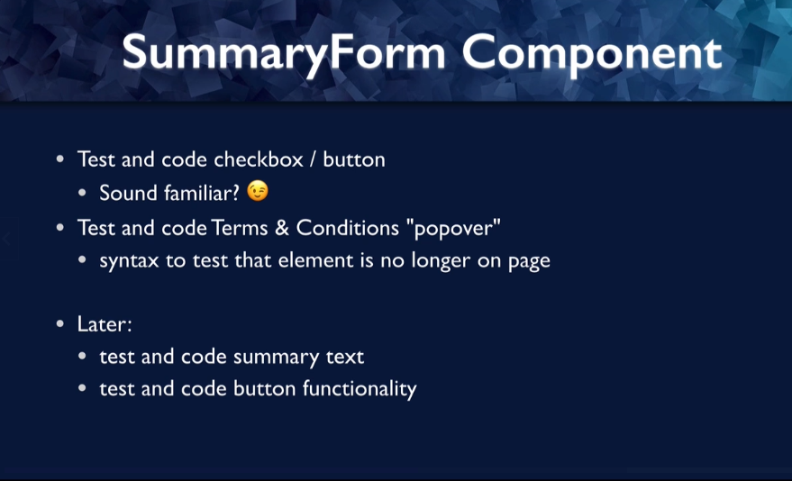

userEvent instead of FireEvent for hover and unhover

npm install --save-dev @testing-library/user-event @testing-library/dom

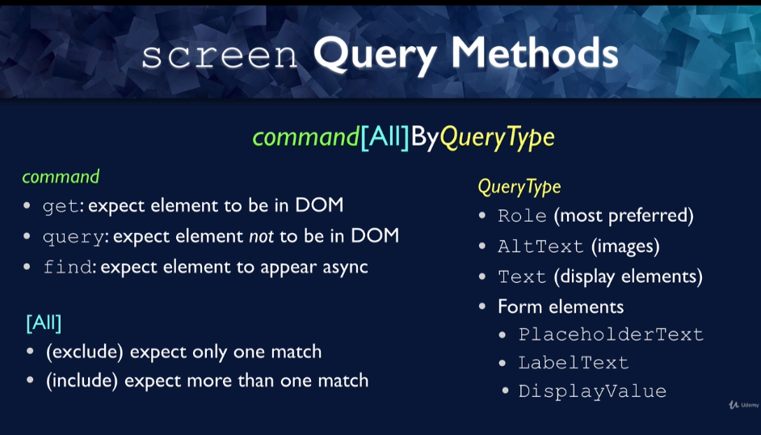

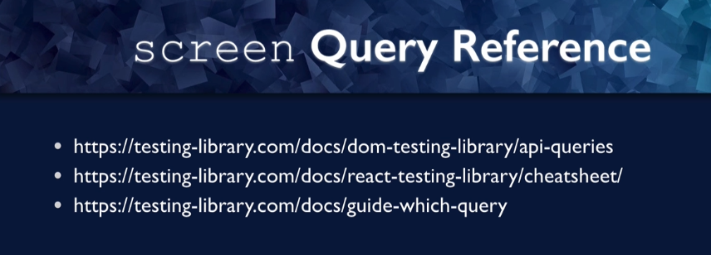

1. Query will are available with everyone (user sees)
2. Semantic queries
3. Test IDs

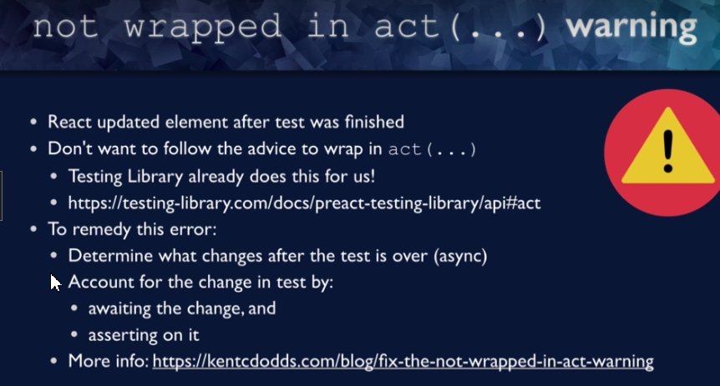

In SummaryForm.jsx

import React, { useState } from 'react';

import {Form} from 'react-bootstrap';

import {Button} from 'react-bootstrap';

import { Popover } from 'react-bootstrap';

import { OverlayTrigger } from 'react-bootstrap';

const SummaryForm = () => {

  const [tcChecked, setTcChecked] = useState(false);

  const popover = <Popover id="popover-basic">

    <Popover.Body>

      No ice cream will actually be delivered

    </Popover.Body>

  </Popover>

  const checkboxLabel = (

    <span>

      I agree to

      <OverlayTrigger  placement='right' overlay={popover}>

        <span style={{ color: 'blue' }}>Terms and Conditions</span>

        </OverlayTrigger>

    </span>

  );

  return (

    <Form>

      <Form.Group controlId="terms-and-condtions">

        <Form.Check type="checkbox" checked={tcChecked} onChange={(e) => setTcChecked(e.target.checked)} label={checkboxLabel} /></Form.Group>

      <Button variant="primary" type="submit" disabled={!tcChecked}>

        Confirm Order

      </Button>

    </Form>

  )

}

export default SummaryForm

In SummaryForm.test.js

import { render, screen ,waitForElementToBeRemoved} from '@testing-library/react';

import SummaryForm from '../SummaryForm';

import userEvent from '@testing-library/user-event';

test('Initial condition', () => {

  render(<SummaryForm />)

  const checkbox = screen.getByRole('checkbox', {

    name: /terms and conditions/i

  });

  expect(checkbox).not.toBeChecked();

  const confirmButton = screen.getByRole('button', { name: /confirm order/i });

  expect(confirmButton).toBeDisabled();

});

test('Checkbox enables button on first click and disables on second click', () => {

  render(<SummaryForm />);

  const checkbox = screen.getByRole('checkbox', { name: /terms and conditions/i });

  const confirmButton = screen.getByRole('button', { name: /confirm order/i });

  userEvent.click(checkbox);

  expect(confirmButton).toBeEnabled();

  userEvent.click(checkbox);

  expect(confirmButton).toBeDisabled();

});

test('popover responds to hover',async () => {

  render(<SummaryForm />);

  // popover starts out hidden

  const nullPopover = screen.queryByText(/no ice cream will actually be delivered/i);

  expect(nullPopover).not.toBeInTheDocument();

  // popover appears upon mouseover of checkbox label

  const termsAndConditions = screen.getByText(/terms and conditions/i);

  userEvent.hover(termsAndConditions);

  const popover = screen.getByText(/no ice cream will actually be delivered/i);

  expect(popover).toBeInTheDocument();

  //popover disappears when we mouse out

  userEvent.unhover(termsAndConditions);

  let nullPopoverAgain;

  await waitForElementToBeRemoved(() =>

    nullPopoverAgain = screen.queryByText(/no ice cream will actually be delivered/i));

  expect(nullPopoverAgain).not.toBeInTheDocument();

})

Simulating Server

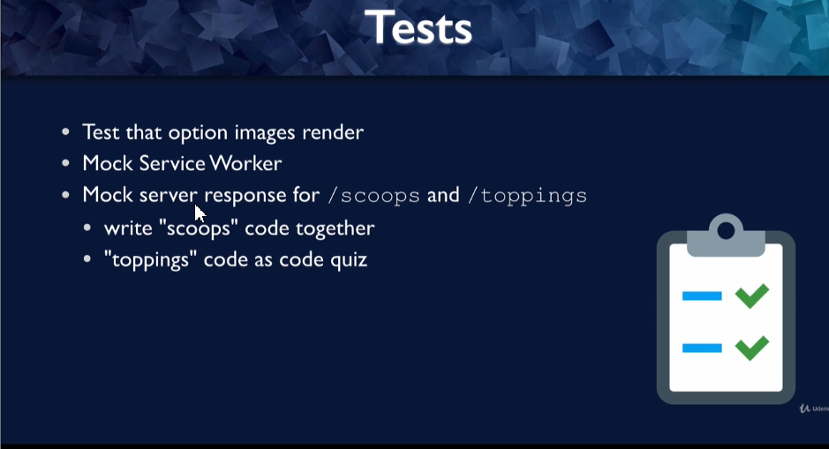

Mock Service Worker

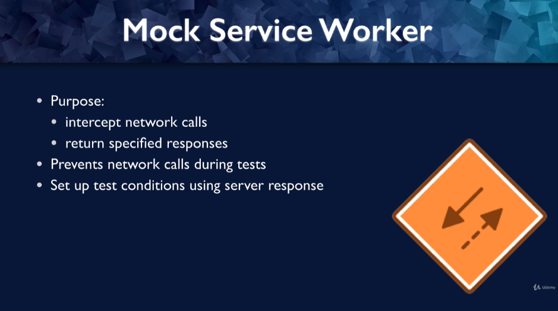

npm install msw

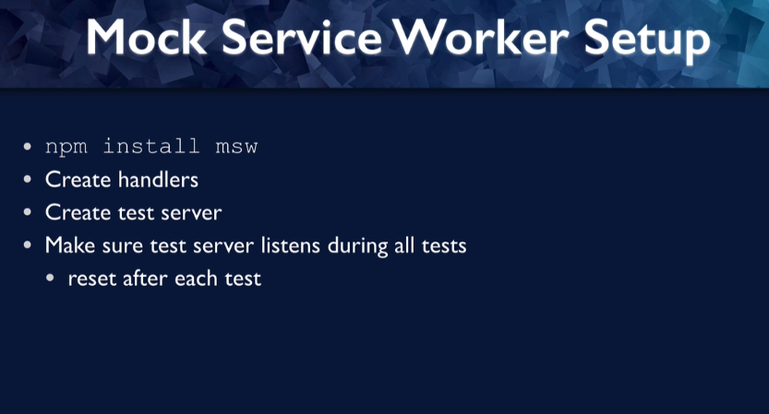

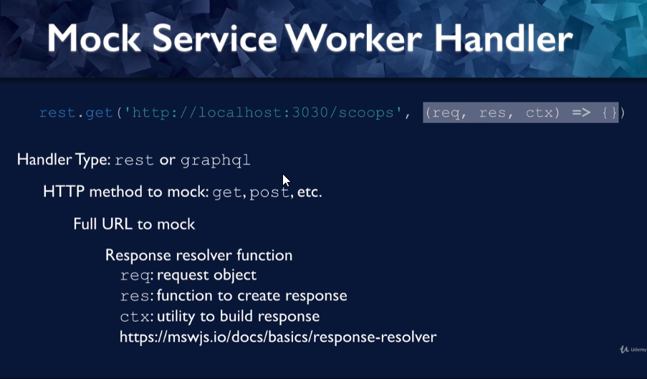

In src/mocks/handler.js

import { rest } from 'msw';

export const handlers = [

  rest.get('http://localhost:3030/scoops', (req, res, ctx) => {

    return res(

      ctx.json([

        { name: 'Chocolate', imagePath: '/images/chocolate.png' },

        { name: 'Vanilla', imagePath: '/images/vanilla.png' },

      ])

    );

  }),

];

In src/mocks/server.js

import { setupServer } from 'msw/node';

import { handlers } from './handlers';

export const server = setupServer(...handlers);

Final thing is modify create-react-app to intercept

// jest-dom adds custom jest matchers for asserting on DOM nodes.

// allows you to do things like:

// expect(element).toHaveTextContent(/react/i)

// learn more: https://github.com/testing-library/jest-dom

import '@testing-library/jest-dom';

import { server } from './mocks/server';

// Establish API mocking before all tests

beforeAll(() => server.listen());

afterEach(() => server.resetHandlers());

afterAll(() => server.close());

string and numbers should be checked with toBe

Objects and Arrays should be checked with toEqual

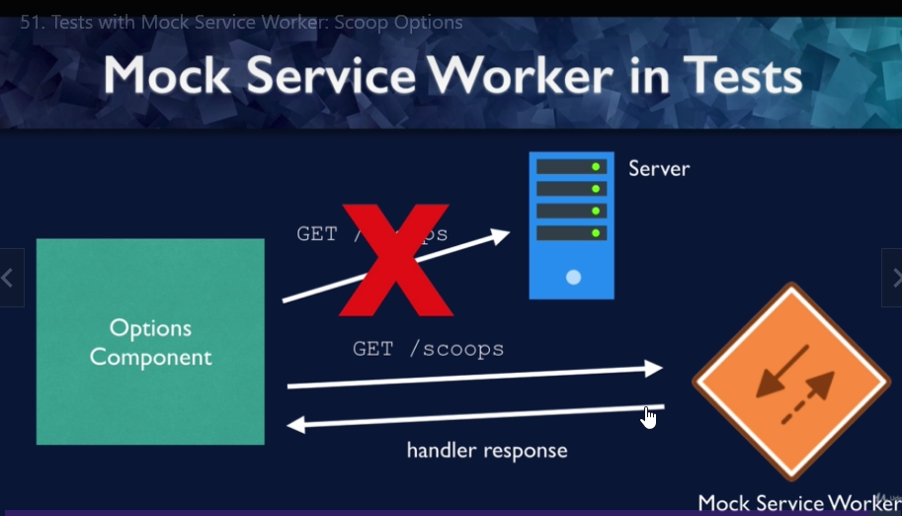

import { render, screen } from '@testing-library/react';

import Options from './Options';

test('displays image for each scoop option from server', () => {

  render(<Options optionType="scoops" />);

  const scoopImages = screen.getAllByRole('img', { name: /scoop$/i });

  expect(scoopImages).toHaveLength(2);

  const altText = scoopImages.map((element) => element.alt);

  expect(altText).toEqual(['Chocolate scoop', 'Vanilla scoop']);

});

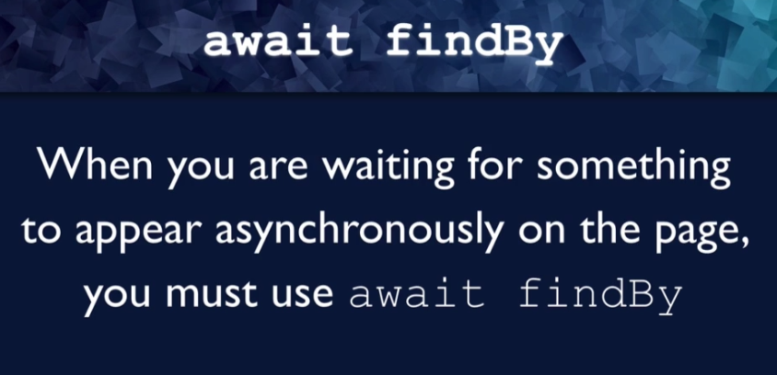

In Options.jsx

import React, { useEffect,useState } from 'react';

import axios from 'axios';

import ScoopOption from './ScoopOption';

import { Row } from 'react-bootstrap';

const Options = ({ optionType }) => {

  const [items, setItems] = useState([]);

  useEffect(() => {

    axios.get(`http://localhost:3030/${optionType}`).then((res) => {

      setItems(res.data);

    }).catch((error) => {

      // TODO : handle error response later

    });

  }, [optionType]);

  const ItemComponent = optionType === 'scoops' ? ScoopOption : null;

  const optionItems = items.map((item) => <ItemComponent key={item.index} name={item.name} imagePath={item.imagePath}/>);

  return (

    <Row>{optionItems}</Row>

  )

}

export default Options

In ScoopOptions.jsx

import React from 'react';

import { Col } from 'react-bootstrap'

const ScoopOption = ({name,imagePath}) => {

  return (

    <Col xs={12} sm={6} md={4} lg={3} style={{ textAlign:'center'}}>

      <img src={`https://localhost:3030/${imagePath}`}

        alt={`${name} scoop`}

        style={{ width: '75%' }}

      />

    </Col>

  )

}

export default ScoopOption

In Options.test.js

import { render, screen } from '@testing-library/react';

import Options from '../Options';

test('displays image for each scoop option from server', async () => {

  render(<Options optionType="scoops" />);

  const scoopImages = await screen.findAllByRole('img', { name: /scoop$/i });

  expect(scoopImages).toHaveLength(2);

  const altText = scoopImages.map((element) => element.alt);

  expect(altText).toEqual(['Chocolate scoop', 'Vanilla scoop']);

});

Async…await..findAllByRole

Error handling

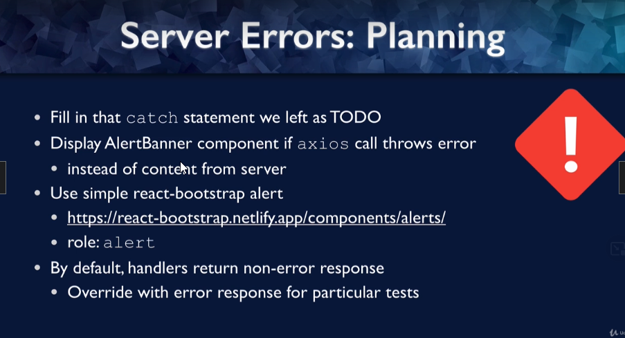



To run just only one tests

Jest options 🡪 p for pattern for particular file to run

test.only 🡪 to run only one test

test.skip 🡪 to skip the particular test

 const alerts = await screen.findAllByRole('alert', { name: 'An unexpected error occured. Please try again later.' });

The above code will wait for only one promise (server call) but in our code there are two server calls and our test should wait for two server call (promises to return) – in this case use waitFor

await waitFor(async () => { const alerts = await screen.findAllByRole('alert', { name: 'An unexpected error occured. Please try again later.' }) });

In OrderEntry.test.js

import { render, screen , waitFor} from '@testing-library/react';

import OrderEntry from '../OrderEntry';

import { rest } from 'msw'; // override the server data with error

import { server } from '../../../mocks/server';

test('handles error for scoops and toppings routes', async () => {

  server.resetHandlers(

    rest.get('http://localhost:3030/scoops', (req, res, ctx) => {

      res(ctx.status(500));

    }),

    rest.get('http://localhost:3030/toppings', (req, res, ctx) => {

      res(ctx.status(500));

    }),

  );

  render(<OrderEntry />);

  await waitFor(async () => { const alerts = await screen.findAllByRole('alert', { name: 'An unexpected error occured. Please try again later.' }) });

  expect(alerts).toHaveLength(2);

});

In OrderEntry.jsx

import React from 'react'

import Options from './Options';

const OrderEntry = () => {

  return (

    <div>

      <Options optionType="scoops" />

      <Options optionType="toppings" />

    </div>

  )

}

export default OrderEntry;

In Options.jsx

import React, { useEffect,useState } from 'react';

import axios from 'axios';

import ScoopOption from './ScoopOption';

import { Row } from 'react-bootstrap';

import ToppingOptions from './ToppingOptions';

import AlertBanner from '../common/AlertBanner';

const Options = ({ optionType }) => {

  const [items, setItems] = useState([]);

  const [error, setError] = useState(false);

  useEffect(() => {

    axios.get(`http://localhost:3030/${optionType}`).then((res) => {

      setItems(res.data);

    }).catch((error) => {

      setError(true)

    })

  }, [optionType]);

  if (error) {

    return <AlertBanner />

  }

  const ItemComponent = optionType === 'scoops' ? ScoopOption : ToppingOptions;

  const optionItems = items.map((item) => <ItemComponent key={item.index} name={item.name}

    imagePath={item.imagePath} />);

  return (

    <Row>{optionItems}</Row>

  )

}

  export default Options

In AlertBanner.jsx

import { Alert } from "react-bootstrap";

import React from 'react'

const AlertBanner = ({ message, variant }) => {

  const alertMessage = message || "An unexpected error occured. Please try again later.";

  const alertVariant = variant || 'danger';

  return (

    <Alert variant={alertVariant} style={{ backgroundColor: 'red' }}>

      {alertMessage}

    </Alert>

  )

}

export default AlertBanner;

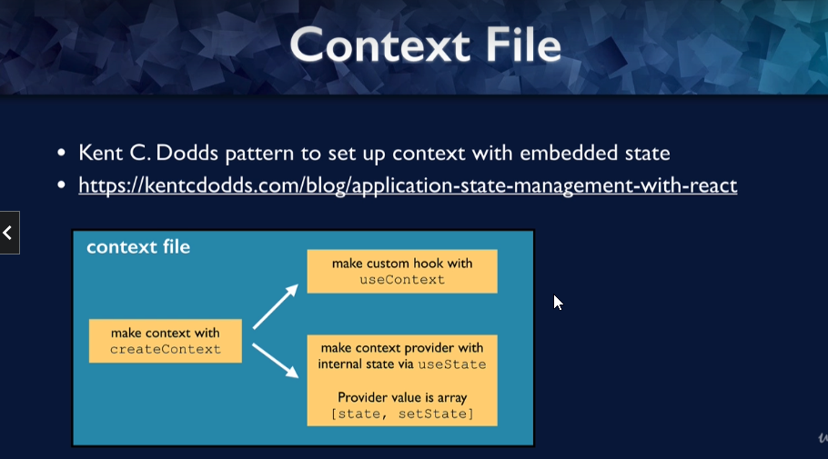

import { render, screen } from "@testing-library/react";

import userEvent from "@testing-library/user-event";

import { OrderDetailsProvider } from "../../../contexts/OrderDetails";

import Options from "../Options";

test('update scoop subtotal when scoops change', () => {

  render(<Options optionType="scoops" />,{wrapper:OrderDetailsProvider}); // wrapping an provider

  // make sure total starts out $0.00

  const scoopsSubtotal = screen.getByText('Scoops total: $', { exact: false });

  expect(scoopsSubtotal).toHaveTextContent('0.00');

  const vanillaInput = await screen.findByRole('spinbutton', { name: 'Vanilla' });

  userEvent.clear(vanillaInput);

  userEvent.type(vanillaInput, '1');

  expect(scoopsSubtotal).toHaveTextContent('2.00');

  // update chocolate scoops to 2 and check subtotal

  const chocolateInput = await screen.findByRole('spinbutton', { name: 'Chocolate', });

  userEvent.clear(chocolateInput);

  userEvent.type(chocolateInput, '2');

  expect(scoopsSubtotal).toHaveTextContent('6.00');

});

userEvent.clear(element) 🡪 clear the event

userEvent.type(element,text) 🡪 to type something

Custom Render 🡪 overwrite the default render from the testing-library 🡪 for redux, routing library etc…

test-utils.js

import { render } from '@testing-library/react';

import { OrderDetailsProvider } from '../contexts/OrderDetails';

const renderWithContext = (ui, options) => {

  render(ui, { wrapper: OrderDetailsProvider, ...options });

}

export * from '@testing-library/react';

export { renderWithContext as render };

Import {render} from ‘test-utils’;

Screen.debug() 🡪 print what DOM looks like at that point

If getBy fails, then try await findBy

